**Methods: QUALITY CONTROL FOR TCGA**

1. Use MultiAssayExperiment to create two matrices: one for RNASeqGene/ RNASeq2GeneNorm and one for copy number (CNVSNP/ CNASNP).
   1. In these matrices we included primary solid tumors only
   2. Complete cases across assays
   3. Mapped copy number ranges to gene symbols
   4. Extracted matrices with same dimensions ( same samples and same genes)🡪 features as the rows and samples are cols.
2. Pairwise correlations between RNAseq expression data and copy number data(log2 copy numbers) of corresponding gene across all the tumor samples in common were calculated using Pearson correlation.
3. Calculate correlations between matching columns
4. Diagonal of correlations in (2).
5. Calculate correlations between non-matching columns
   1. Lower and upper triangular matrices of correlations in (2)—off diagonal values.
6. Use a robust method to fit normal (or if necessary, other parametric) distributions to each of the above. Fisher’s transformation may be necessary.

**\*For steps 1-2 use function genomicqc()**

* Input: MultiAssayExperiment object subsetted by the 2 assays with tumor samples only.
  + Copy number ranges have to be disjoint
* Output: Matrix with sample wise correlations between expression data and copy number.

1. We first use the function `genes ()` in the GenomicFeatures package to extract all gene symbols from the Homo.sapiens TxDb object.
2. We extract the ExpressionSet features and use these to subset the object in (1).
3. We use the object in (2) to map the copy number ranges to gene symbols and create a subset of the RangedRaggedAssay
4. We use the `assay()` function in (3).
5. Find intersection
6. Extract matrices with expression data and copy number
7. Calculate pairwise Pearson’s correlations and return this as a matrix

Things that I need to update:

1. coerce `RangedRaggedAssay` to `RaggedExperiment`🡪 use updateObject() (Done!)
2. Disjoint RE in the function as an input instead of the RRA
3. mRNA and gistica and gistict

EXAMPLES( will update when I fix the issues with the correlations)

**Bladder Urothelial Carcinoma (using RNASeqGene and CNVSNP)**

**Correlations between RNASeqGene and CNVSNP for bladder cancer OVERALL**



**Correlations for matching samples ( correlations on the diagonal)**

**Correlations for non-matching samples (off diagonal correlations--- L and U triangular matrices)**

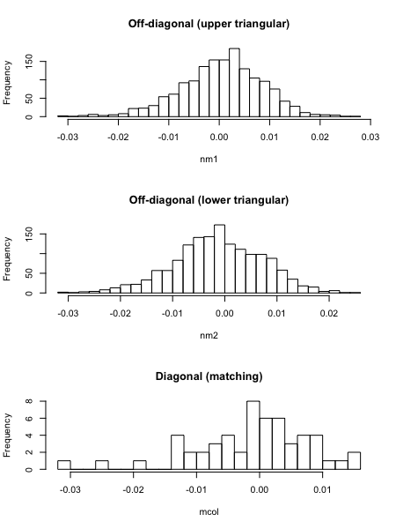

**Ovarian serous cystadenocarcinoma**





**Uterine Carcinosarcoma**



